Drug Design Project: Winter 2017

Shah Ishmam Mohtashim, e-mail: [sishmam51@gmail.com](mailto:sishmam51@gmail.com), Cell: 01740773515

**Drug: *Epoxiconazole***

Quantum computation of the drug ***Epoxiconazole*** and molecular docking with *Oxidoreductase* [PDB id: 3ibd].

**Quantum Computation:**

Epoxiconazole drug was drawn in Gaussian software and optimization, frequency, and molecular orbital calculations in gas phase using HF/3-21G level of theory was done. The following is the image of the drug Epoxiconazole after optimization and frequency calculation:

**Image: Epoxiconzole after optimization and frequency calculation with labels and symbols**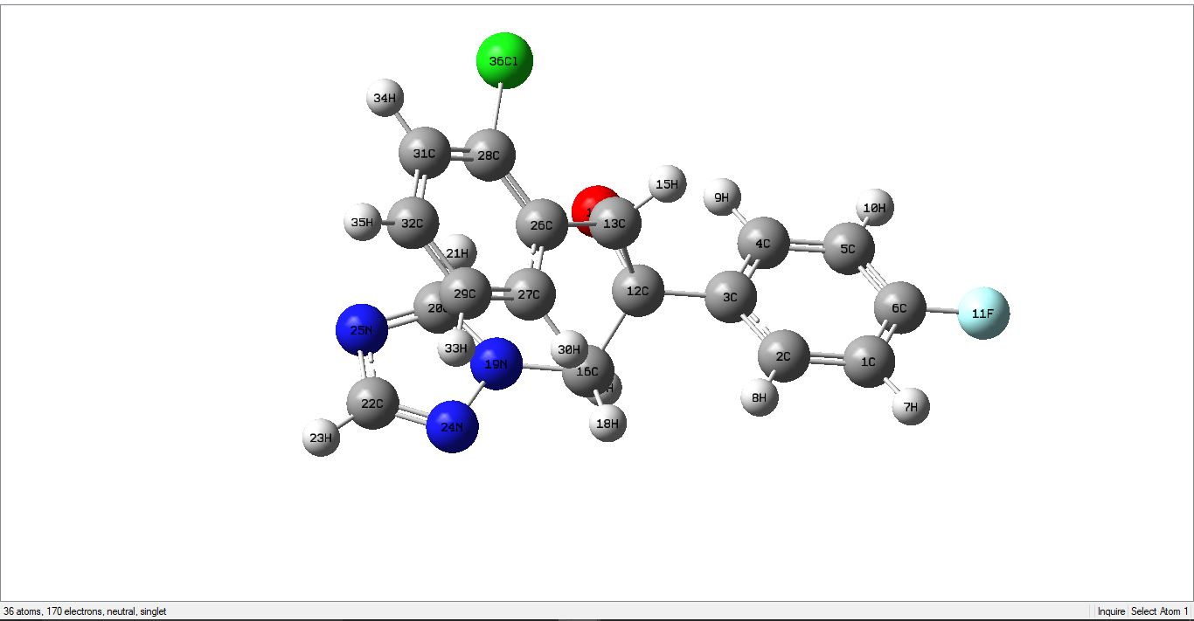

**\*The result of frequency calculation was examined and no imaginary frequency was found.**

**Table of selective bond distance [3 distances] of Epoxiconazole in gas phase:**

|  |  |
| --- | --- |
| Label | Distance |
| (28C)-(36Cl) | 1.815 |
| (14O)-(12C) | 1.466 |
| (24N)-(19N) | 1.398 |

**Table of selective bond angle [3 angles] of Epoxiconazole in gas phase:**

|  |  |
| --- | --- |
| Label | Angle |
| (3C)-(4C)-(5C) | 29.9 |
| (23H)-(22C)-(25N) | 123.1 |
| (34H)-(31C)-(28C) | 34.3 |

**Table for HOMO, HOMO-1, HOMO-2, LUMO, LUMO+1 and LUMO+2, homo-lumo gap of Epoxiconazole**

|  |  |
| --- | --- |
| **LUMO+2** | **0.12335** |
| **LUMO+1** | **0.11647** |
| **LUMO** | **0.11250** |
| **HOMO** | **-0.35192** |
| **HOMO-1** | **-0.35573** |
| **HOMO-2** | **-0.36223** |

**\*Humo-lumo gap: 0.11250 - (-0.35192) = 0.46442**

**Table for the electronic energy (E), enthalpy (H), Gibbs free energy (G) and dipole moment (Debye) of Epoxiconazole**

|  |  |
| --- | --- |
| Electronic energy (E) | -1440.369012 |
| Enthalpy (H) | -1440.368068 |
| Gibbs free energy (G) | -1440.434870 |
| Dipole moment (Debye) | 3.8028 Debye |

**Image for HOMO and LUMO orbital of Epoxiconazole:**

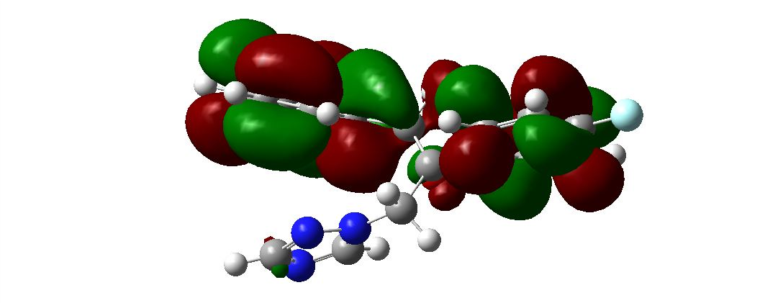

**Molecular Docking:**

Molecular docking between *Epoxiconazole* and the receptor protein oxidoreductase by *Autodock Vina*

**Grid box size**

|  |  |
| --- | --- |
| center_x = 20.2575  center_y = 11.0403  center_z = 24.3481 | size_x = 60.1667110634  size_y = 65.2751292419  size_z = 66.7326102257 |

**Binding energies**

|  |  |  |  |  |  |
| --- | --- | --- | --- | --- | --- |
| Ligand |  | Binding Affinity | rmsd/ub |  | rmsd/lb |
| 3ibdoptimized_EPOXYCONAZOLEPDB |  | -7 | 0 |  | 0 |
| 3ibdoptimized_EPOXYCONAZOLEPDB |  | -6.5 | 15.577 |  | 14.468 |
| 3ibdoptimized_EPOXYCONAZOLEPDB |  | -6.4 | 36.729 |  | 35.199 |
| 3ibdoptimized_EPOXYCONAZOLEPDB |  | -6.4 | 36.811 |  | 33.799 |
| 3ibdoptimized_EPOXYCONAZOLEPDB |  | -6.4 | 40.395 |  | 38.183 |
| 3ibdoptimized_EPOXYCONAZOLEPDB |  | -6.4 | 15.687 |  | 14.19 |
| 3ibdoptimized_EPOXYCONAZOLEPDB |  | -6.3 | 4.055 |  | 2.636 |
| 3ibdoptimized_EPOXYCONAZOLEPDB |  | -6.3 | 3.939 |  | 2.553 |
| 3ibdoptimized_EPOXYCONAZOLEPDB |  | -6.1 | 33.776 |  | 32.399 |

**5 non-bonding interactions of drug with amino acids**

|  |  |  |  |  |  |  |  |  |  |  |  |  |  |  |  |  |
| --- | --- | --- | --- | --- | --- | --- | --- | --- | --- | --- | --- | --- | --- | --- | --- | --- |
| Name | Parent | Distance | Category | Types | From | From Chemistry | To | To Chemistry | Angle DHA | Angle HAY | Theta | Theta 2 | Gamma | Closest distance |  | Closest atom distance |
| :UNK0:HN - A:LYS225:O | Ligand Non-bond Monitor | 2.45307 | Hydrogen Bond | Conventional Hydrogen Bond | :UNK0:HN | H-Donor | A:LYS225:O | H-Acceptor | 130.345 | 160.635 |  |  |  |  |  |  |
| :UNK0:H17 - A:LYS225:O | Ligand Non-bond Monitor | 2.97961 | Hydrogen Bond | Carbon Hydrogen Bond | :UNK0:H17 | H-Donor | A:LYS225:O | H-Acceptor | 124.758 | 109.88 |  |  |  |  |  |  |
| :UNK0:H21 - :UNK0:O | Ligand Non-bond Monitor | 2.3282 | Hydrogen Bond | Carbon Hydrogen Bond | :UNK0:H21 | H-Donor | :UNK0:O | H-Acceptor | 110.777 | 93.826 |  |  |  |  |  |  |
| :UNK0 - A:TYR235 | Ligand Non-bond Monitor | 4.02348 | Hydrophobic | Pi-Pi Stacked | :UNK0 | Pi-Orbitals | A:TYR235 | Pi-Orbitals |  |  | 33.468 | 15.371 | 18.112 | 3.618 |  |  |
| :UNK0 - A:PRO106 | Ligand Non-bond Monitor | 3.95435 | Hydrophobic | Pi-Alkyl | :UNK0 | Pi-Orbitals | A:PRO106 | Alkyl |  |  |  |  |  |  |  |  |
| :UNK0 - A:LYS225 | Ligand Non-bond Monitor | 3.93833 | Hydrophobic | Pi-Alkyl | :UNK0 | Pi-Orbitals | A:LYS225 | Alkyl |  |  |  |  |  |  |  |  |

**Picture of non bonding interaction with protein visibility**

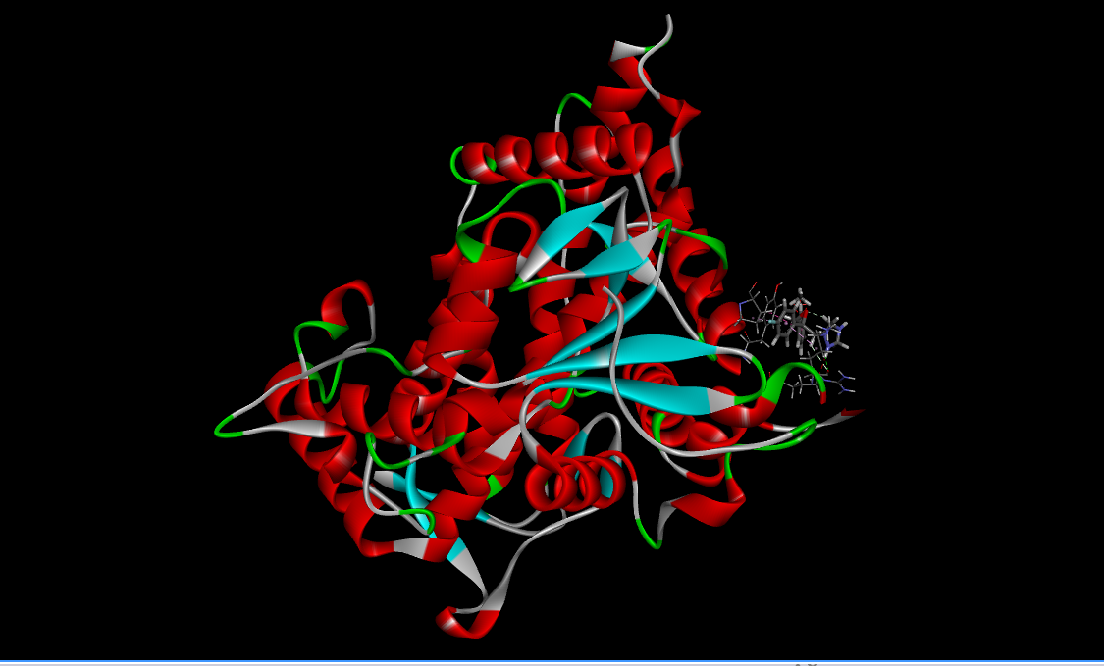

**Picture of non bonding interaction without protein visibility**

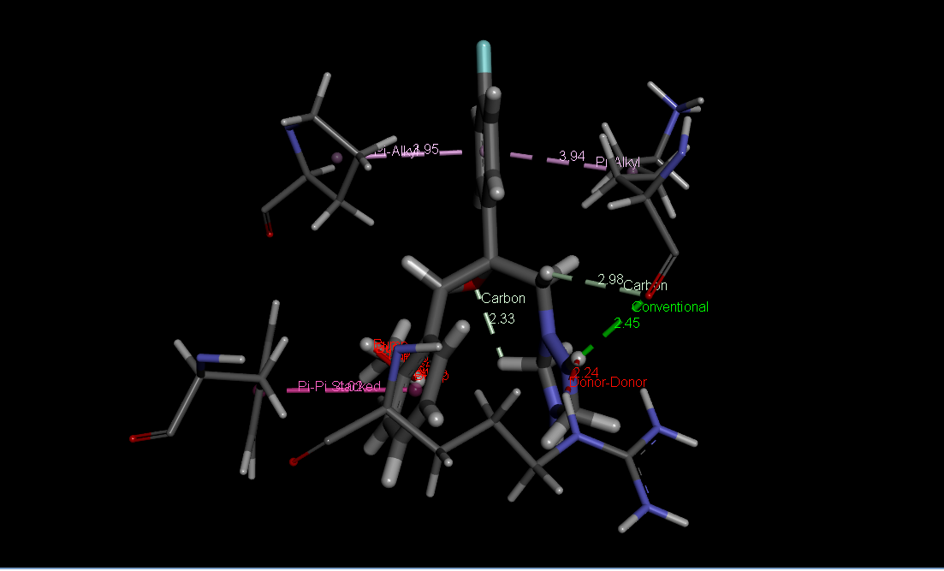

Aurein 1.2 peptide (Sequence: GLFDIIKKIAESF) is an antifungal peptide. Five structure of this peptide has been designed by PEP-FOLD3.5 then docked against 3IBD protein in patchdock.

**Comparison of the Score, Area and ACE of five model peptides**

**Score Area ACE**

|  |  |  |  |
| --- | --- | --- | --- |
| Model 1 | 7362 | 1030.90 | 295.70 |
| Model 2 | 7260 | 958.90 | 63.68 |
| Model 3 | 7386 | 1129.40 | -41.46 |
| Model 4 | 7418 | 1094.20 | -83.15 |
| Model 5 | 7494 | 975.90 | 130.20 |

**Non bonding interaction image of these 5 peptides model with the protein by *Discovery Studio*.**

Non bonding interaction image of Model 1 with the protein

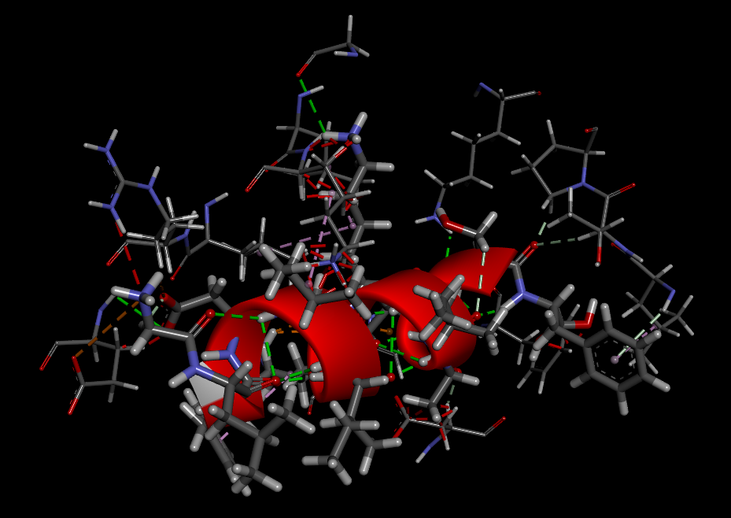

Non bonding interaction image of Model 2 with protein

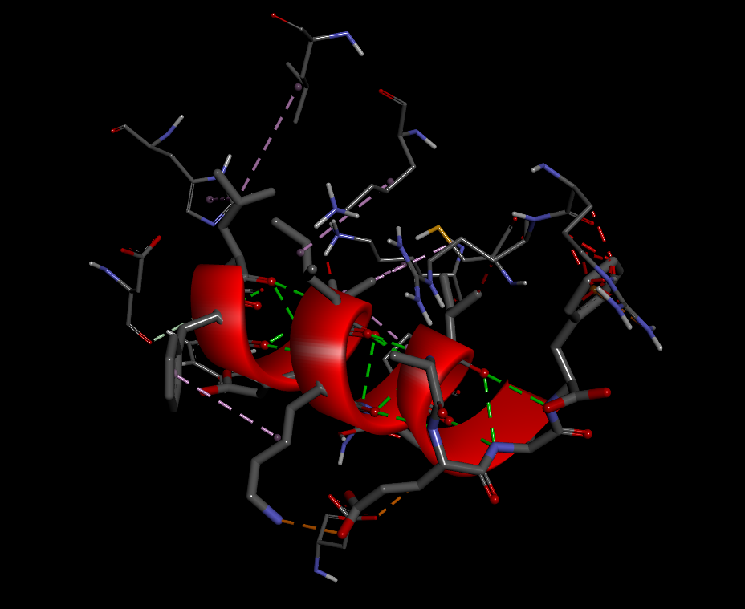

Non bonding interaction image of Model 3 with protein

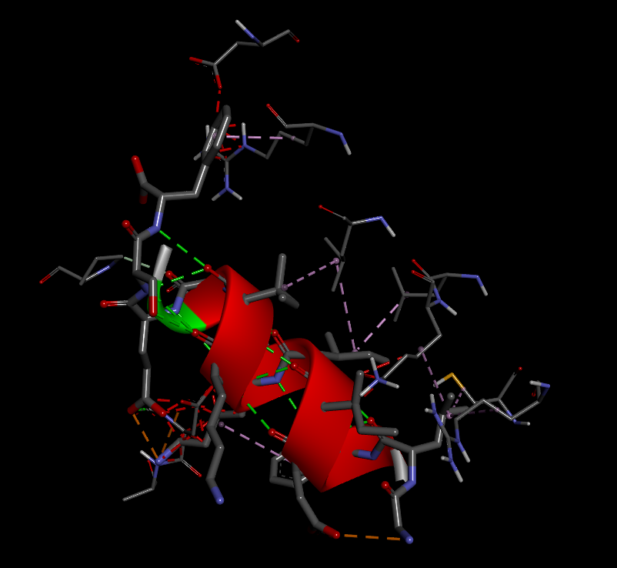

Non bonding interaction image of Model 4 with protein

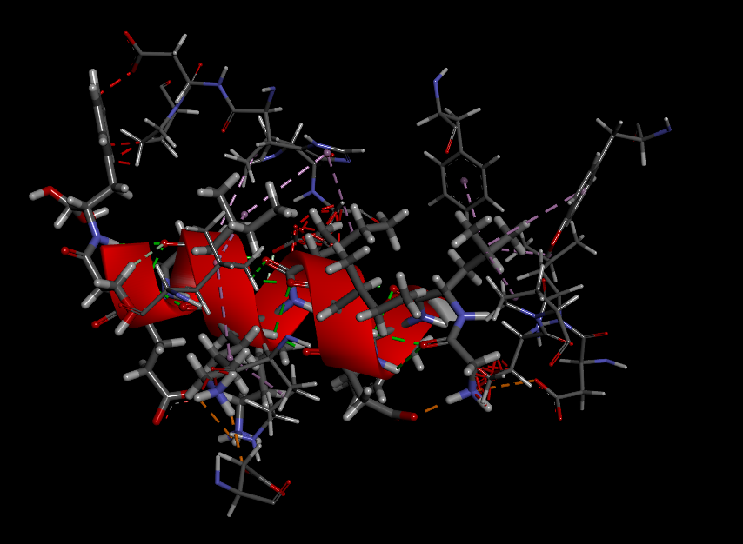

Non bonding interaction image of Model 5 with protein

